Best Practices for Designing Shopping Cart and

Checkout Interfaces

This best practice is a summary of the publication on dack.com with a few minor extra points.
Here under is the most ideal Shopping Cart and Checkout interface enumerated. For full detail one is referred to: http://www.dack.com/web/shopping_cart.html

The Shopping Cart: Basic Elements

- Item number
- Quantity: in an HTML form box (so the quantity can be changed by the user)
- Item description: hyperlinking the item description back to the detail page
- Item availability
- Price
- Currency converter
- Subtotal
- Shipping & Handling: Shipping options
- Shipment Total
- A "Remove Item from Cart" option
- One "Update Quantities" or "Update Cart" option: update buttons for each item in a shopping cart is not recommended.
- Checkout
- Continue shopping
- Search for next item

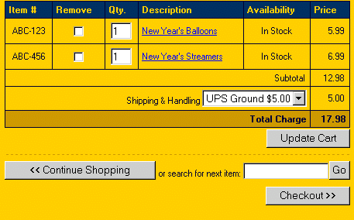

The Persistent Shopping Cart
An excellent feature that makes e-commerce sites more usable and a more comfortable shopping experience is the persistent shopping cart. This is a mini-cart that's visible from every page within the site, once an item has been added to the shopping cart. It provides persistent, useful feedback about the items the user has added, and how much money the user has spent.

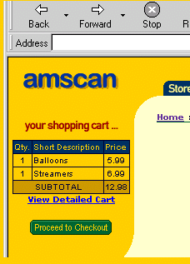

The Checkout Process
The elements of a typical checkout process are as follows:

- Request email address and password (login)
- Request mailing address and phone number
- Request ship-to address (if different from the buyer's billing address)
- Request shipping method (e.g. Standard, Second Day, Next Day)
- Request payment method (e.g. Visa, MasterCard, etc. or by check)
- Submit order
- Order confirmation

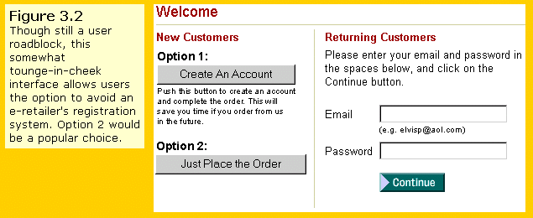

Grouping together on a single, well-designed page is the best practice users do not become frustrated with scrolling pages. In fact, several users in their studies did become frustrated with having to click through several short pages in order to get to information.

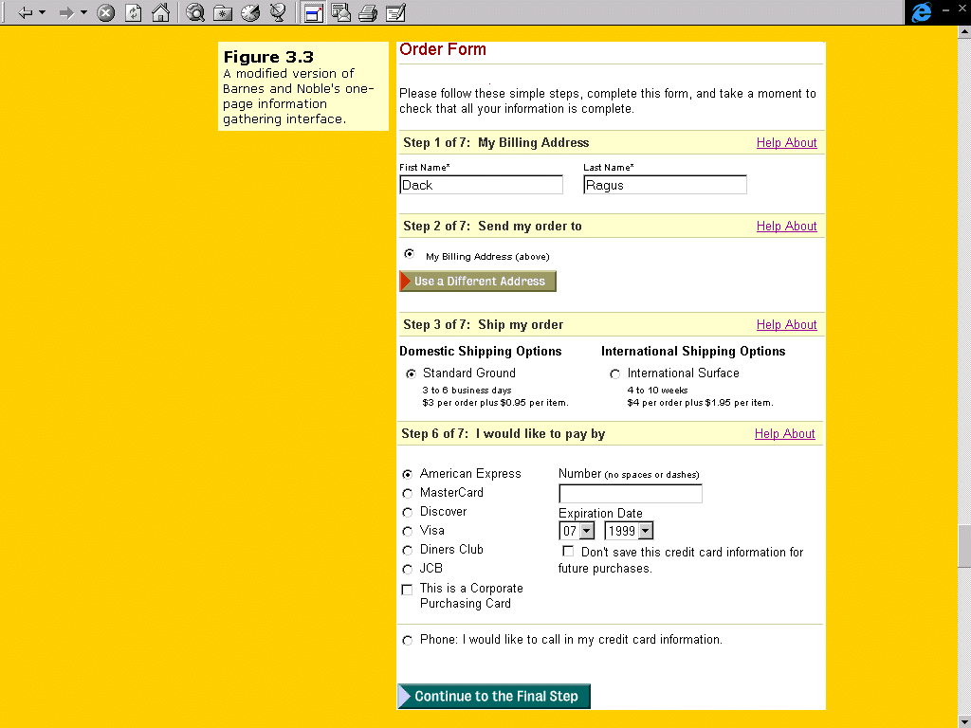

In the figure above the option: “I want to pay by check”
should be added.
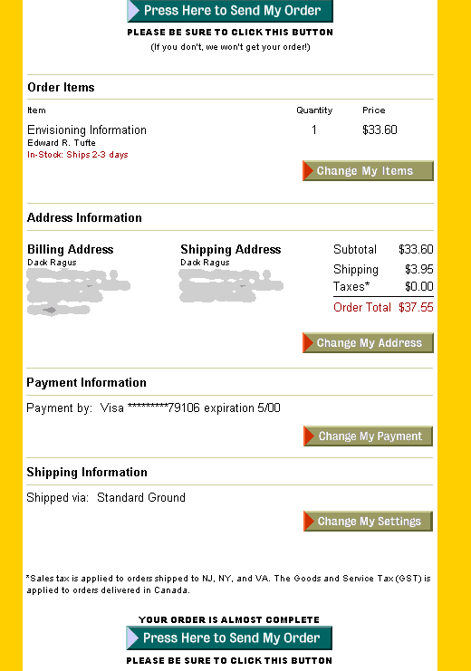
The best way to instill user confidence that their order is accurate is to provide them with a complete order summary with the option to edit any of the order’s elements.

Order confirmation
A well-designed confirmation page looks a lot like a printed invoice, and should be printer-friendly.
This confirmation page is a good opportunity for e-retailers to announce a sale or special promotion for its online customers.

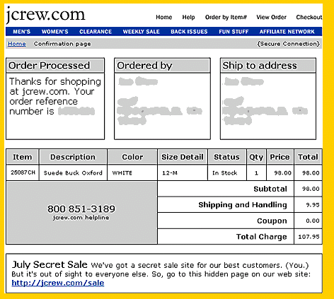

General remarks
- Button Gravity this term describes users' tendency to scroll to the bottom of a form to look for the lone, "magic" submit button.

- Any step in the checkout process that is not directly related to completing the online transaction is a roadblock to completing the transaction, and makes the procedure more complicated, more time consuming, and for many users, more irritating. This is the equivalent of waiting in the checkout line at the grocery store while being forced to register before buying groceries. Would you buy milk and bread at that store again?

- Reducing the total number of steps increases the likelihood of user success.

